**Part 2**

Attached are two csv files.  One contains a list of data science skills gleaned from job postings.  The other contains corporate tweets.  Apply what you learned in Part I to one of the attached files, submit a summary of your results and outline the steps you took. Have fun with this and experiment with different operators. Feel free to use any other documents if you wish.

**Example:**

I made 2 separate folders for each of the attached files and called in both files using ‘Process Documents from Files’



I had to connect the *inp* to the *wor* on the ‘PDfromFiles’ box

**

Double click on ‘Process Data from Files’, drop in ‘Tokenize’ & ‘Filter Stopwords’ click up to the main process and run (blue arrow pointing to the right is Run) to get back to main environment hit the small blue arrow that is pointing up.

Results from Run

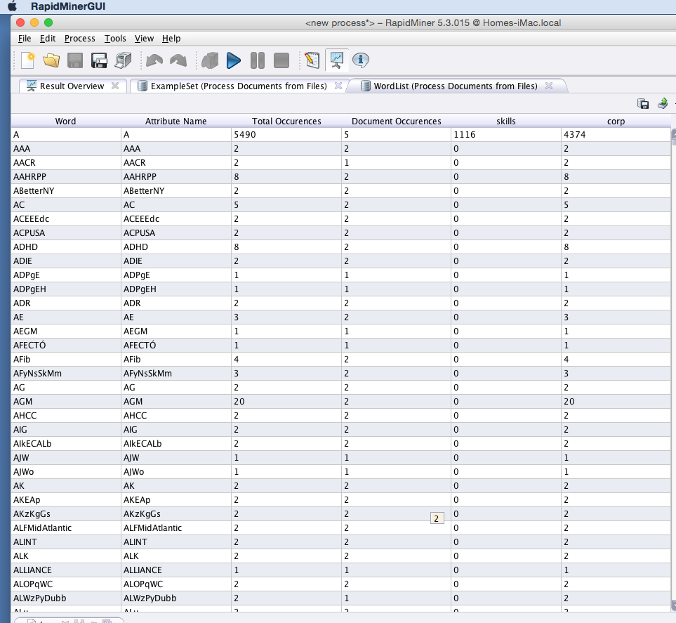

If you want to see graph differences between your two files (the ones posted here or any that you have). When in Plot View, click on a few of the Attributes to see the differences between I then added a Classification & Regression Model ‘Naïve Bayes’ (Modeling->C&R-> Bayesian Modeling-> Naïve Bayes) add so the box crosses the upper line and run the 2 files. Once on the ‘Sample Distribution’ tab you can click on charts and select different words or characters to view frequency differences. You can also change the type of chart if you wish.



**